

Cairo University

Faculty of Engineering

Department of Computer Engineering

**CMPN-446**

**Image Processing and Computer Vision**

**Fog Detection, Fog Removal**

**And Color Restoration**

***Submitted by:***

Khadija Khaled - 1180377

Yomna Tarek - 1180494

Habiba Assem - 1180450

Momen Ahmad - 1180481

***Submission Date***: 31/12/2022

# ***Table of Contents:***

Table of Contents 2

Fog Detection 3

Used Algorithm 3

Evaluation and Analysis 4

Fog Removal 9

Used Algorithm 9

Evaluation and Analysis 10

Color Restoration 16

Used Algorithm 16

Evaluation and Analysis 17

Workload Division 20

**Conclusion 20**

**References 21**

***Fog Detection***

* ***Used Algorithms:***

In this module, we need to detect the fog present in images and its degree. This is done by following several steps:

1. **Sobel Edge Detection**: This first step uses edge detection to differentiate between foggy and sunny images and discard the sunny ones.

We apply the Sobel Edge Detection and then compare the number of edge pixels with a threshold that depends on the image size.

1. **Hough Transform**: The binarized image that resulted from the edge detection is then passed to a Hough Transform function from which we get the hough peaks representing the dominating lines in the image.

These lines usually depict the road lines, which are parallel in reality but intersect in a vanishing point in the picture.

1. **Vanishing Point Calculation**: Transforming the dominating lines equations from Polar to Cartesian form. Calculating Alpha and Beta following the rule:

$α = \frac{- a}{b} , β = \frac{ρ}{b}$

We are able to compute the Y coordinate of the vanishing point:

$$y =\frac{β_{2} - β_{1}}{α_{1}-α_{2}}$$

1. **Sky Segmentation**: In this step we use the Iterative Thresholding Segmentation method to transform the image into a binary image having 2 segments: one for the sky and one for the other elements in the image.
2. **Sky Road End Line**: Here we calculate an approximated line for the limit between the road and the sky. The approximation is done by getting the y coordinate of the intersection between the sky and the road segment at 3 different places.
3. **Comparison**: We compare between the Y coordinate we got from the previous step with the one of the Vanishing point. The degree of fogginess is calculated as follows:

$$Fogginess = \frac{abs(Yvanishing - Y avg)}{Yvanishing} * 100 \%$$

* ***Evaluation and Analysis:***

In this section, we are going to discuss our results and compare our results with the paper and references we followed.

* The output of the first step is whether the picture is sunny or not.

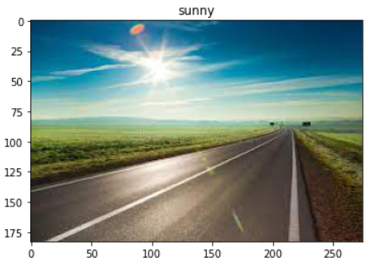

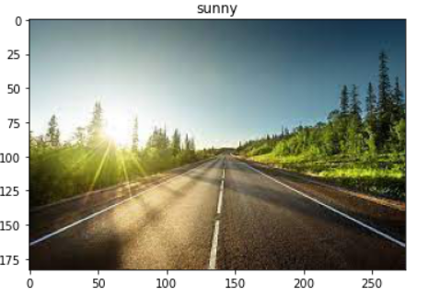

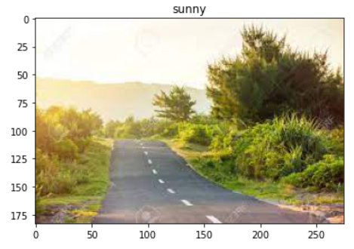

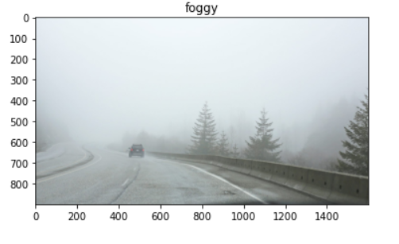

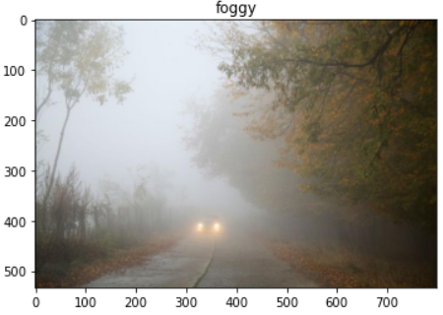

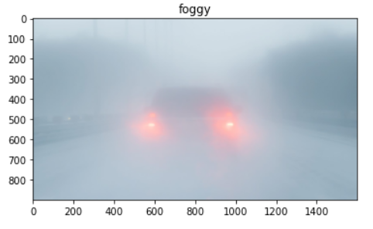

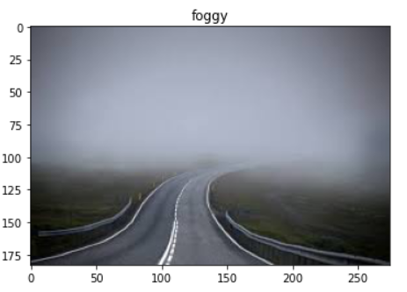

We can evaluate this part by eye, concluding that this algorithm accurately differentiate between sunny images and foggy ones. Even with different degrees of fogginess and different angles of illumination in sunny images. We also tested the algorithm with foggy images having a lot of details and the output was correct.

* The second step is dependent on getting vanishing point correctly.

We used the built in hough transform functions for this part (hough_line,

hough_line_peaks).

So the vanishing point accuracy is dependent on the lines detected above the threshold.

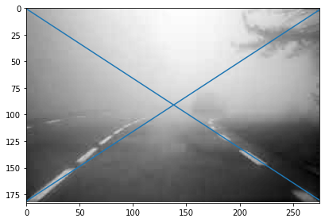

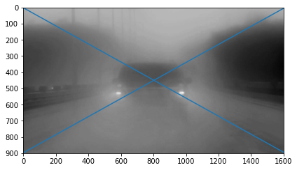

* Sky- Road Endline results are obtained after Sky segmentation based on iterative thresholding on color pixels. As we explained in the previous section, we get the y coordinate of the limit between the two obtained segments from three places in the image (at ¼ , ½ and ¾ of its width) and we average the result to obtain a more accurate y coordinate of the endline.

But the accuracy of this part is also dependent on the efficiency of the sky segmentation step and whether there are trees, cars, panels in the original image as they negatively affect the output average.

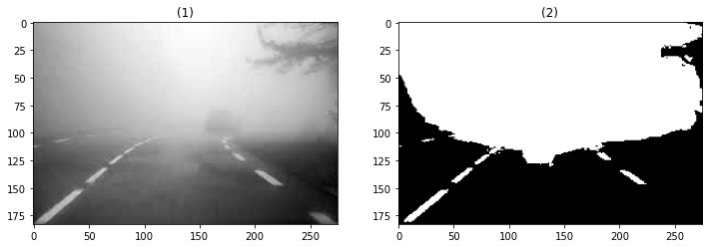

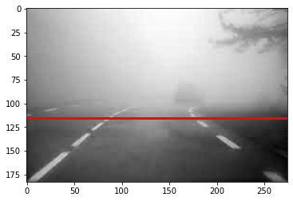

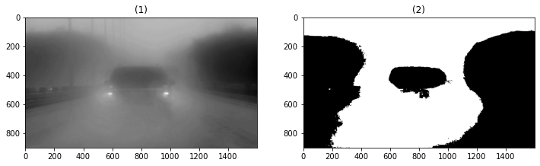

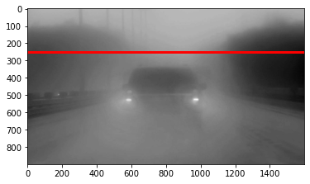

***Fog Removal***

* ***Used Algorithms:***

In this module, we attempted at removing the fog from the foggy image. We followed a famous algorithm called the **Dark Channel Prior Algorithm**. This algorithm mainly consists of 5 steps:

1. **Dark Channel**: From this step we obtain the dark channel of the image by retrieving the channel with the minimum intensity, then applying the minimum filter on the retrieved minimum intensity channel and a structural element (of size 15x15 according to the research paper we followed).
2. **Atmospheric Light Estimation**: In this step, we need to figure out which parts of the image have the fog. The brightest pixels in the hazy image are considered to be the most fog-opaque. According to the paper we followed, we need to pick the top 0.1% brightest pixels in the dark channel image and get their average. The output of this step is called the atmospheric light.
3. **Transmission Estimation**: Transmission is an estimate of how much of the light from the original object is making it through the fog at each pixel. If we remove the fog thoroughly, the image may seem unnatural and we may lose the feeling of depth. So, we can optionally keep a very small amount of fog for distant objects by introducing w = 0.95. Afterwards, we will normalize each channel by the atmospheric light and calculate the transmission using the following equation:

Transmission = 1 - w*dark channel.

1. **Soft Matting**: This step is needed to refine the transmission map by reducing the halos and block artifacts. The paper essentially used only the Guided filter for this step, but for comparison purposes, we used guided, gaussian and bilateral filters.
2. **Recover Scene Radiance**: With the atmospheric light and the transmission map, we can recover the scene radiance. So, we used the following equation to recover the image: J = (I - A) / max(t, t0) + A

Where J is the recovered scene radiance, I is the original image, A is the atmospheric light, t is the refined transmission map and t0 is a small constant, like a lower bound for the transmission map.

* ***Evaluation and Analysis:***

In this section, we are going to discuss our results and compare our results with the paper and references we followed.

* The following shows the output of the dark channel step from our implementation and then the expected output from the research paper respectively. Visually, it can be seen clearly that both outputs are very similar in terms of the positions of the black and gray patches in the dark channel images and this means that our first step was successful in identifying which part of the input image was foggy and which was not.

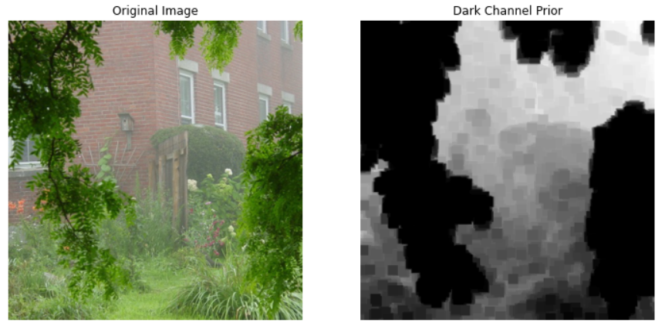

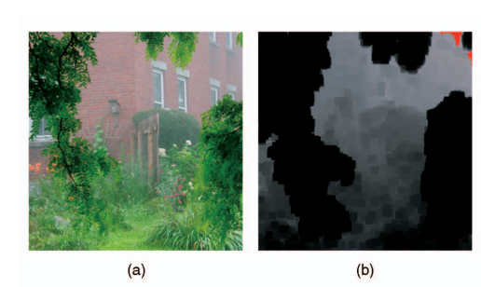

* Another point of comparison between our output and the paper’s is the transmission map produced. The following image shows the dark channel of the image (from our implementation), the transmission image produced by our implementation and the last one is the paper’s output respectively. Since, we can conclude that the transmission map is almost the negative transformation of the dark channel from the transmission equation. It looks like our implementation for getting the transmission map is correct. Furthermore, to make sure we are working correctly, we can see that our produced transmission map is almost identical to the one produced by the paper.

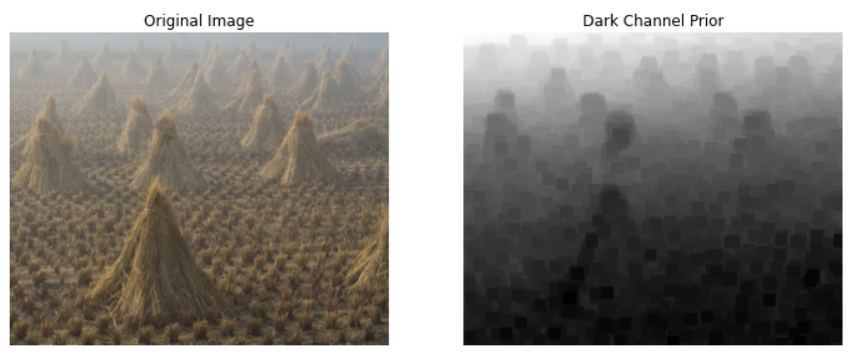

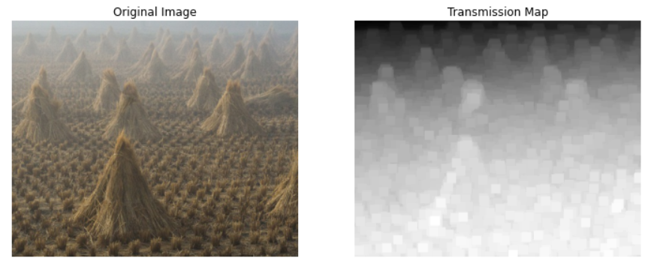

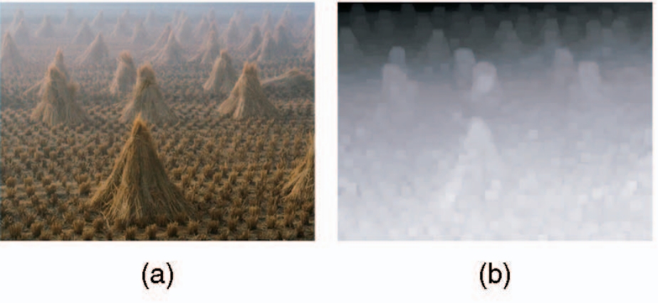

* For the soft matting step, we wanted to refine our transmission map and smooth and blur the outline of the objects in the map because this will help us in eliminating the fog. The output of this section is shown below along with the output from the paper. It is clear that we have succeeded at smoothing the map as the object’s edges are now almost blurry. The results below are somewhat similar, not identical and that is due to the difference in the bilateral filter parameters used in my implementation with the paper’s.

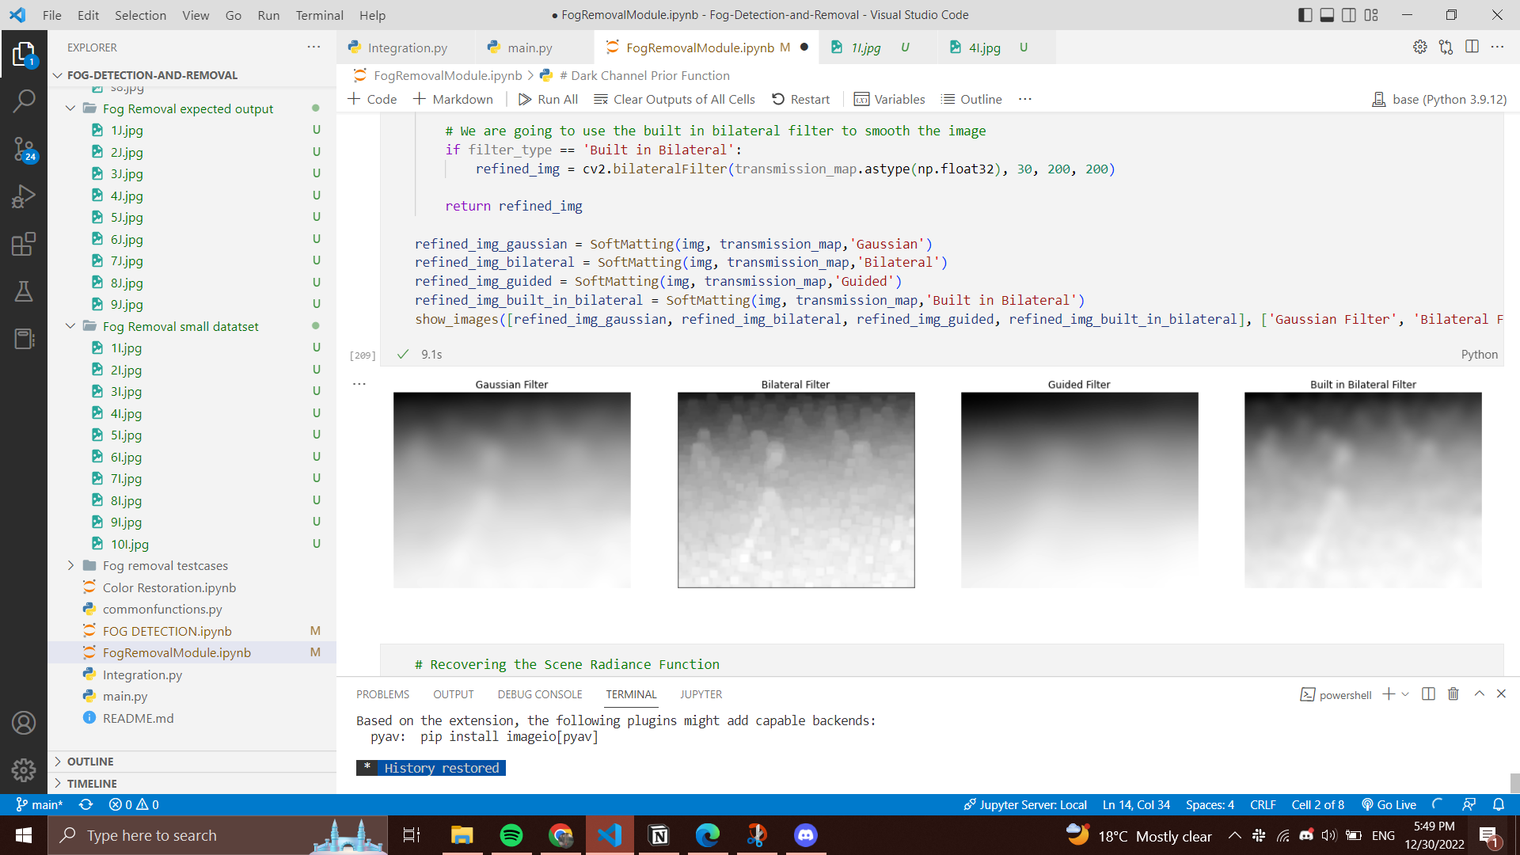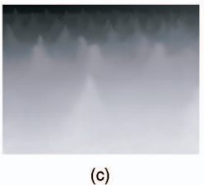

* Last step was to recover the image, and here is our final result along with the expected output from the paper. The aim of the module is achieved, as we have successfully removed the fog from the image. Both our output and the paper’s are similar in terms that no fog can be found in both images. The paper’s image colors might be more enhanced than our output, but nonetheless, the goal we were working towards has been reached and the fog was removed.

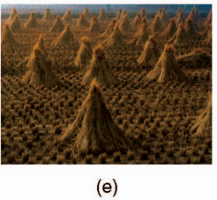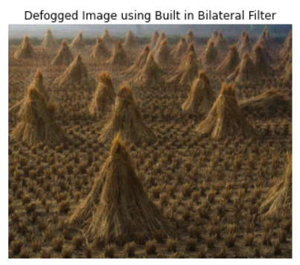

* Another experiment we conducted was to find the histogram for the fogged image and the defogged image and check how the colors were redistributed after the fog removal. The histogram on the left is for the fogged image and the one on the right is for the defogged image. The histogram on the left shows that colors with high values are dominant in the image which is true since the foggy image has a lot of light colors (tending to white color) due to the presence of the fog. Meanwhile, the histogram on the right representing the defogged image shows that the colors with low values are dominant in the image and low frequency with high values and this is due to removal of the fog (i.e removal of bright pixels that made up the fog).

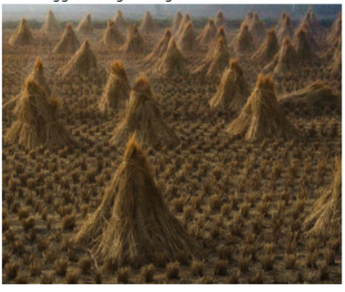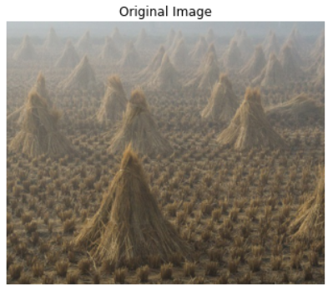

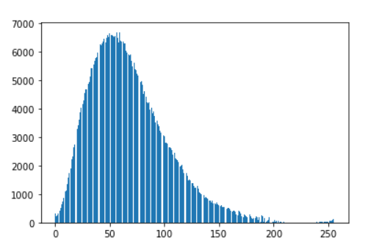

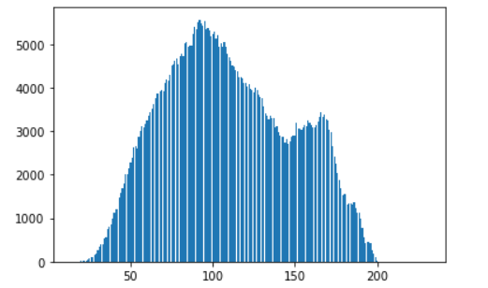

* One last experiment we conducted was to apply gaussian, guided and bilateral filters in the soft matting process and compare between them. The following are the outputs from this module. It can be seen that the guided filter provided the best results in terms of removing the fog and its traces. The output using the guided filter is almost free from any white outlines surrounding the objects which, on the other hand, are obviously visible to our eyes in the output using the bilateral filter. The output using the gaussian filter has some insignificant white outlines, but it looks almost the same as the output using the guided filter.

Another point of comparison worth mentioning between these filters in terms of performance speed, that it was found that the bilateral filter was the slowest filter of them all taking around 0.6s to 2s depending on the size of the image while, the guided and the gaussian took around 0.04s ~ 0.5s depending on the size of the image.

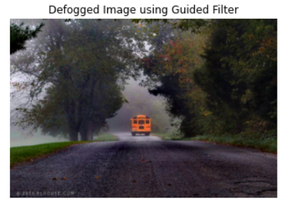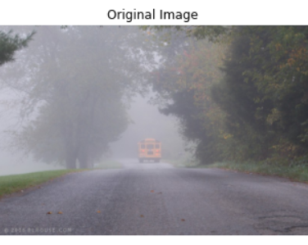

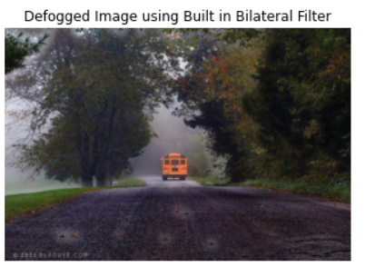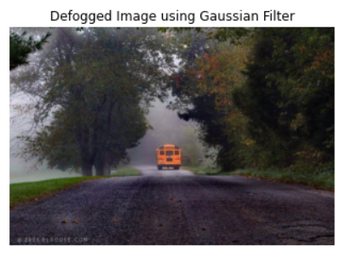

* Point of weakness of this algorithm: This algorithm fails in extreme cases; if the fog is too dense.

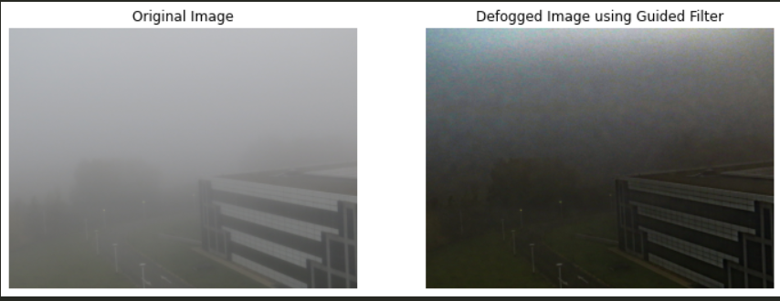

***Color Restoration***

* ***Used Algorithms***

In this module, we attempted to perform color restoration or color correction to the images after fog has been removed from them. Most papers that we found were concerned with specific color correction such as underwater images or more different topics but none were for defogged images so some images which were used for testing were not of defogged roads. We used three white balancing techniques which can be seen in the document. White balancing can be described as the process of removing unrealistic color casts so that objects appear in their right colors mainly by correcting the white elements in the image.

1. **White Patch Algorithm**

This approach tries to mimic how the human visual system works by searching for the lightest patch to use as a white reference. The white patch method is a special case of the Retinex algorithm. We used percentile function to look for the lightest patch and divided the image by it to normalize the image.

1. **Gray World Algorithm**

This assumption is a white balance method that assumes that your scene, on average, is a neutral gray. The Gray World works if we have a good distribution of colors in the scene. Assuming so, the average reflected color is assumed to be the color of the light. Therefore, we can estimate the illumination color cast by looking at the average color and comparing it to gray.This algorithm produces an estimate of illumination by computing the mean of each channel of the image. We calculated the average (mean) for the G channel and divided it by the mean of R and B channels before multiplying the values of the channel by it again as can be seen in code.

1. **Ground Truth Algorithm**

While the two previous methods were built on assumptions on how the color spaces behave on our images. In this method we are going to take a patch that we choose from the image that we can use to recreate our image. This patch’s mean and max will be calculated and used to normalize each channel of the original image. Only one of the mean and max can be used to normalize not both.

* ***Evaluation and Analysis***

In this section, we are going to discuss our results and compare our results with the paper and references we followed.

1. **White Patch**

White patch algorithm results in a brighter image which is considered extremely useful in our case as dealing with defogged images. Below is our result compared with a research paper result.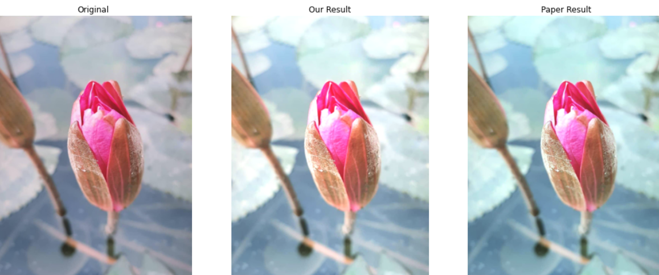

1. **Gray World**

As said before this works really well on images with good color distribution and produces a somehow grayish output. Below is our result compared with a research paper result in the same order.

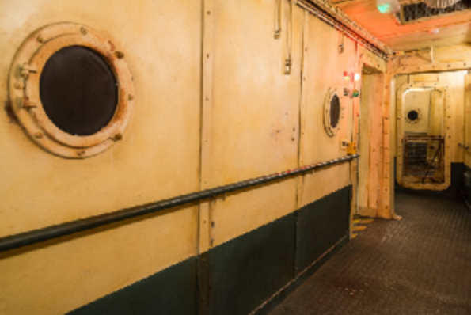 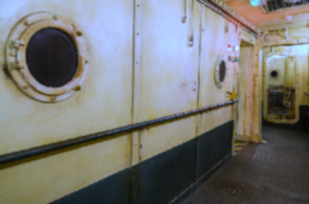 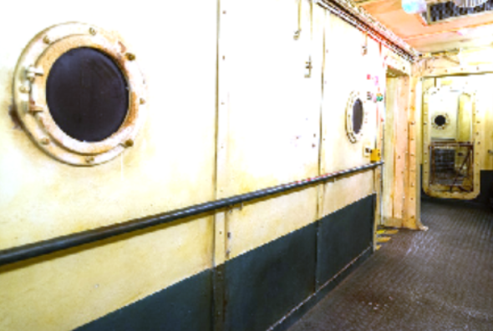

1. **Ground Truth**

The output of this algorithm highly depends on the patch we choose from the image we have. In our project we focused on the results produced by both modes but max mode usually yielded better results.

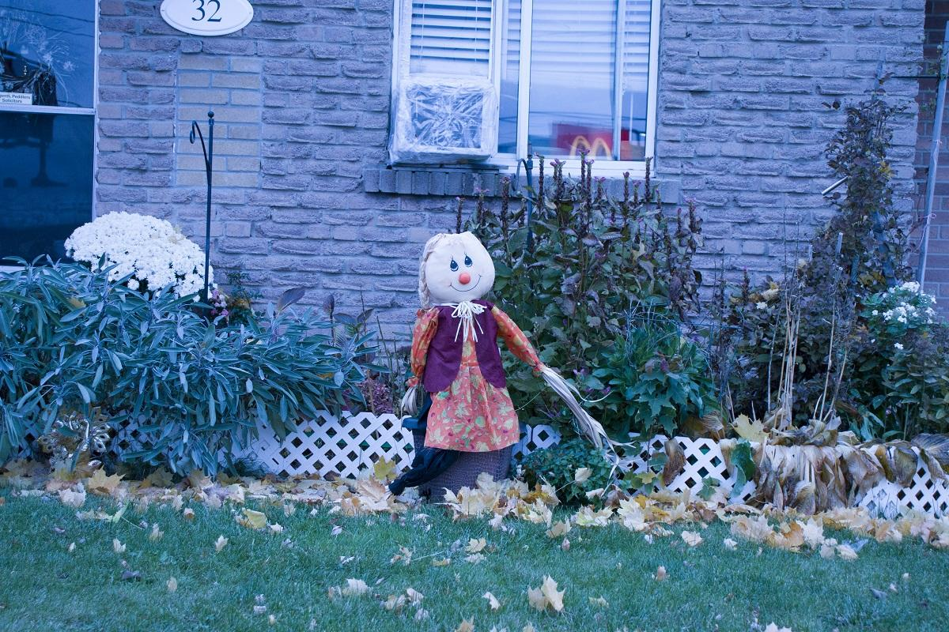 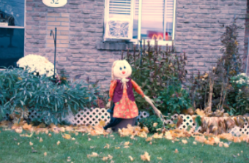 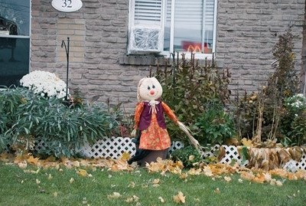

**Comparison between results:**

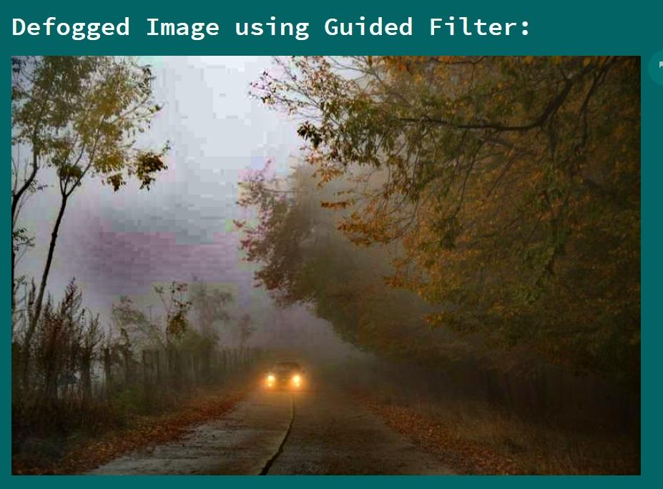 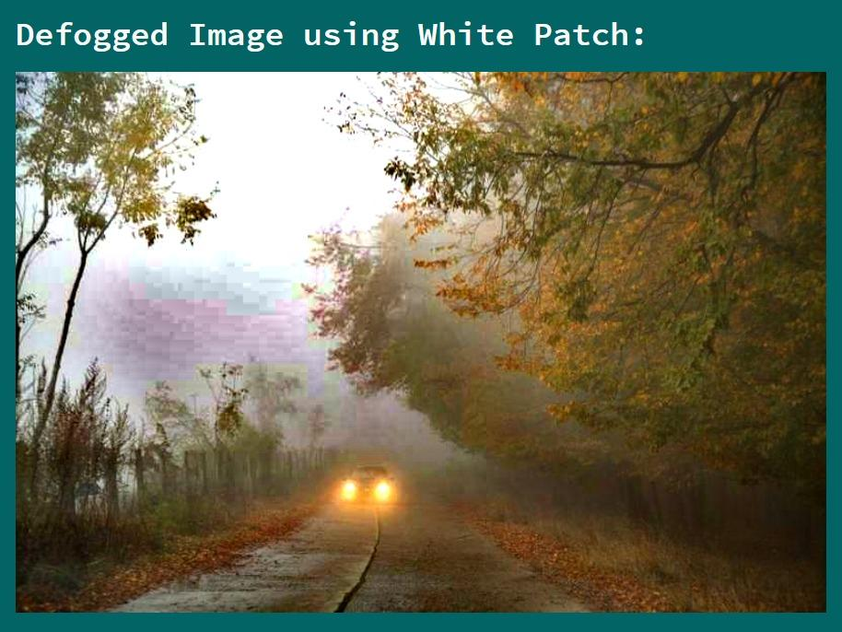

In white patch defogged image some color restoration in the trees can be seen and the fallen leafs on the ground appear brighter as well. Moreover, the road looks clearer and the car can be seen better. The photo appears generally brighter.

 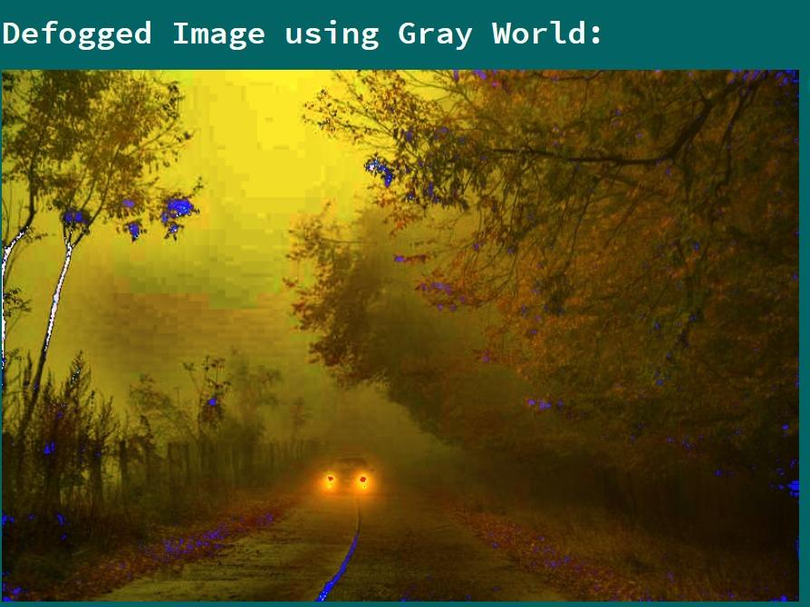

Gray world results on all defogged images were not good at all and this most probably happens because in order for the gray world hypothesis to work there has to be good color distribution which is not the case for the pictures after being defogged.

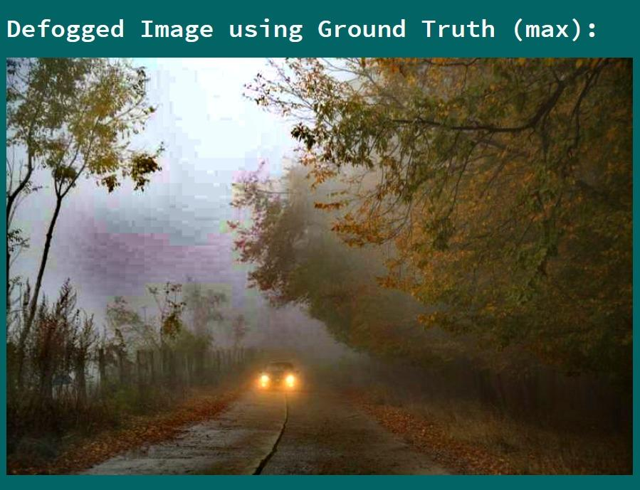 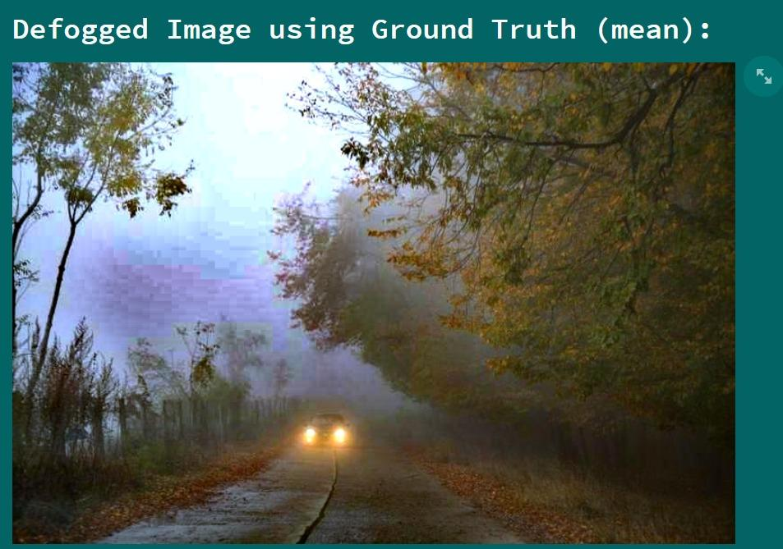

The algorithm was applied using the same patch for the mean and max mode. The mean mode result is brighter while the max is more detailed but both of them are considered an improvement when compared to the original image.

***Workload Division:***

|  |  |
| --- | --- |
| ***Module Name*** | ***Team Member(s)*** |
| Fog Detection | Khadija Khaled and Habiba Assem |
| Fog Removal | Yomna Tarek |
| Color Restoration | Momen Ahmad |

***Conclusion:***

Poor visibility due to fog can be very dangerous and cause fatal car accidents, flight diversions or cancellation. This is because it affects object detection due to low image saturation and low color contrast. Our aim in this project was to detect foggy images, remove the fog, and restore the image using image processing techniques. We have succeeded at reaching our goal, we have conducted plenty of experiments and compared between different approaches and the results of each module and the overall pipeline looks promising according to our analysis and evaluation.

***References:***

* https://www.researchgate.net/publication/224612244_Fog_Detection_System_Based_on_Computer_Vision_Techniques
* <http://web.archive.org/web/20180725124811/http://www.freethatphoto.com/how-dehazing-works-photo/>
* https://www.researchgate.net/profile/Xiaoou-Tang/publication/220182411_Single_Image_Haze_Removal_Using_Dark_Channel_Prior/links/54e9997a0cf25ba91c7f2a3e/Single-Image-Haze-Removal-Using-Dark-Channel-Prior.pdf
* <https://jivp-eurasipjournals.springeropen.com/articles/10.1186/s13640-016-0104-y>
* <https://mattmaulion.medium.com/white-balancing-an-enhancement-technique-in-image-processing-8dd773c69f6>
* https://www.researchgate.net/publication/4035615_Color_correction_for_digital_photographs